Project Development Phase
Model Performance Test

Date | 08 October 2026
Team ID | PNT2022TMIDxxxxxx
Project Name | Auto Ticket Classification using ServiceNow Flow Designer
Maximum Marks | 10 Marks

Model Performance Testing:
Project team shall fill the following information in model performance testing template.
S.No. | Parameter | Values | Screenshot
 | Metrics | Regression Model:  MAE - N/A, MSE - N/A, RMSE - N/A, R2 score - N/A (no regression model)  Classification Model:  Confusion Matrix - Not applicable (keyword rules, not a trained model)  Accuracy Score - 100% (2 of 2 executed test tickets classified correctly)  Classification Report - INC00511 (“My college Has issue with Network”) → Network / Wi-Fi; INC00512 (“Projector not turning on”) → Hardware / Projector | 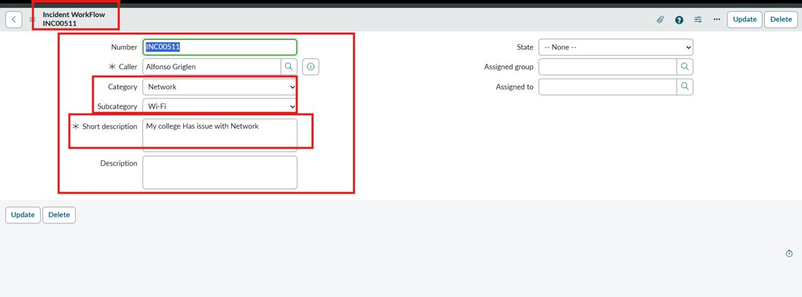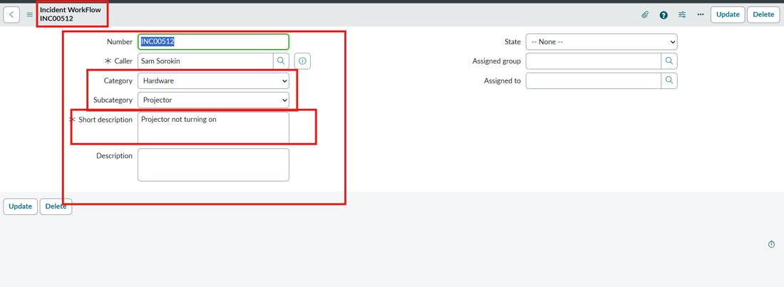
 | Tune the Model | Hyperparameter Tuning - Not applicable (no-code rule-based flow; conditions can be edited directly in Flow Designer)  Validation Method - Manual scenario testing: create a ticket with Caller and Short description, save, reload the form, verify Category / Subcategory, then check System Logs → Emails for the notification | 